 A New Method for Wireless Synchronization in TDOA-UWB Indoor location System

In positioning, if TDOA method is used for coordinate calculation, time synchronization between UWB base stations is required. Time synchronization can be carried out by wired synchronization or wireless synchronization.

The UWB positioning system consists of Anchor node, Reference node, Tag and server.

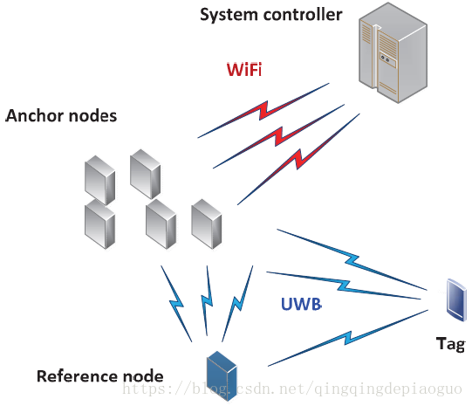

Base station and reference base station are deployed on the coordinates of known points in space. The tag positioning process is as follows:

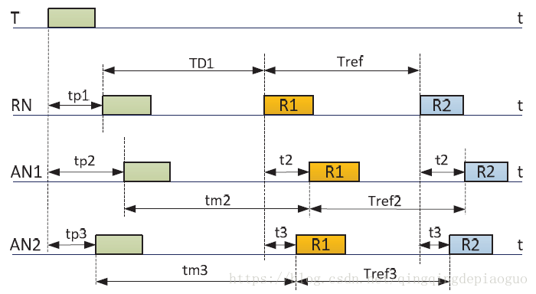

Combined with the figure above, the steps are as follows:

1. The tag T is broadcast once in the positioning space (any data can be sent);
2. The base station and the reference base station in the positioning space are in the receiving state and can receive the broadcast data in step (1), so each device will trigger to generate a receiving timestamp TP1, TP2 and TP3;
3. After the reference base station receives the broadcast, it converts the working mode to the transmitting mode, and broadcasts R1 content once after a fixed delay (TD1, set by itself) (the broadcast content can be distinguished from the label T, and any data can be sent); After the base station receives the broadcast of (2), the working mode remains unchanged, or the base station is in the receiving mode;
4. In step (3), after the base station broadcast data is referenced, all base stations will receive the content of R1, thus triggering the generation of the receiving time stamp. T2 and T3 are the arrival time. After the base station and the reference base station have been deployed in the positioning space (the relative distance remains unchanged), T2 and T3 are known;
5. After the reference base station broadcasts R1 content, it broadcasts R2 content again after a fixed delay (Tref);
6. All the stations will pick up the R2 broadcast again; End of positioning.

For the base station, a timestamp can be generated when receiving the broadcast, so Tm2, Tref2, TM3 and Tref3 are known measurements. T2 and T3 are also known, because after the base station and the reference base station are deployed, the relative distance and arrival time remain unchanged.

The TDOA calculation process is as follows:

TDOA21 = tp3 - tp2 = tm2 - tm3 + t3 -t2

For tm2 and tm3, the measured values cannot be directly used, and need to be calibrated:



Where tm2m is the measured value;

Trefn also needs to be filtered:



At this point, the algorithm ends.